Sprint-4

**Train The Model On IBM**

**Train The Model on IBM Watson**

|  |  |
| --- | --- |
| Date | 18 Nov 2022 |
| Team ID | PNT2022TMID36166 |
| Project Name | Classification of Arrhythmia by Using Deep Learning with 2-D ECG Spectral Image Representation |

TASK:

Train The Model on IBM Watson:

GO ON WATSON SERVICES (SCREEN SHOT):

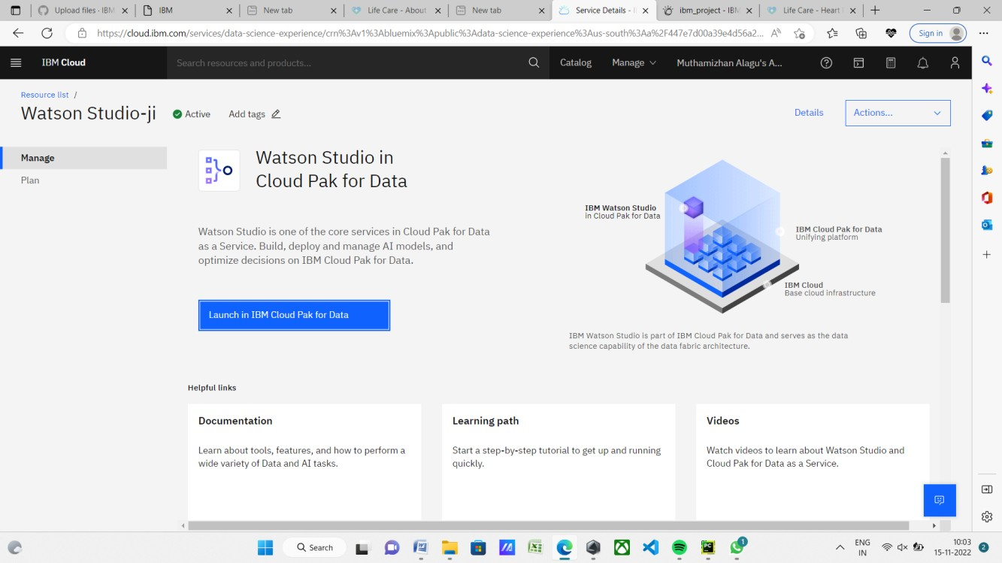

GO ON NEW PROJECT (SCREEN SHOT):

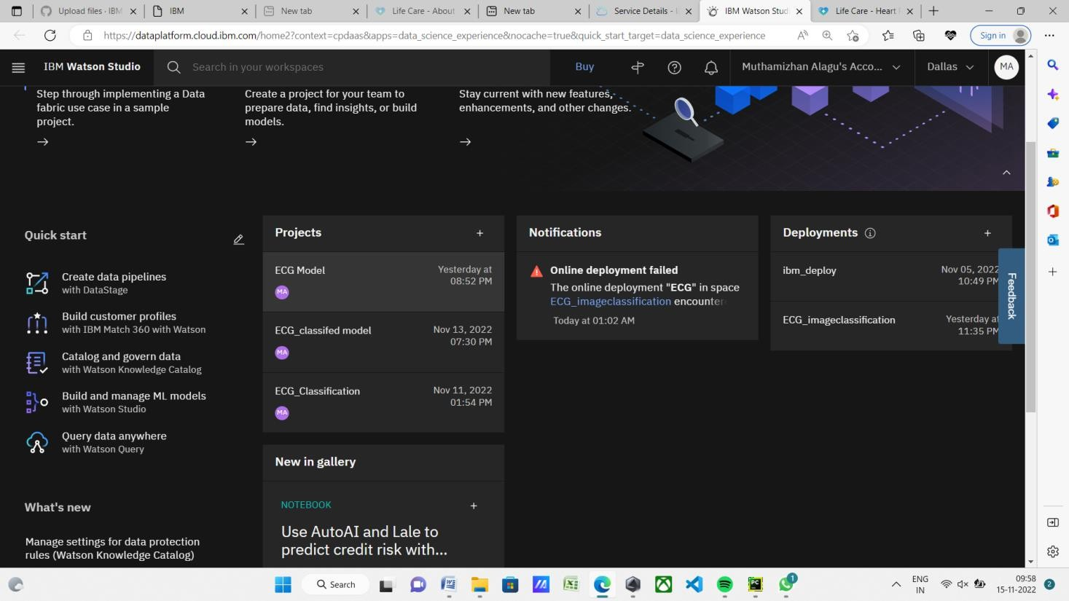

GO ON ASSEST (SCREEN SHOT):

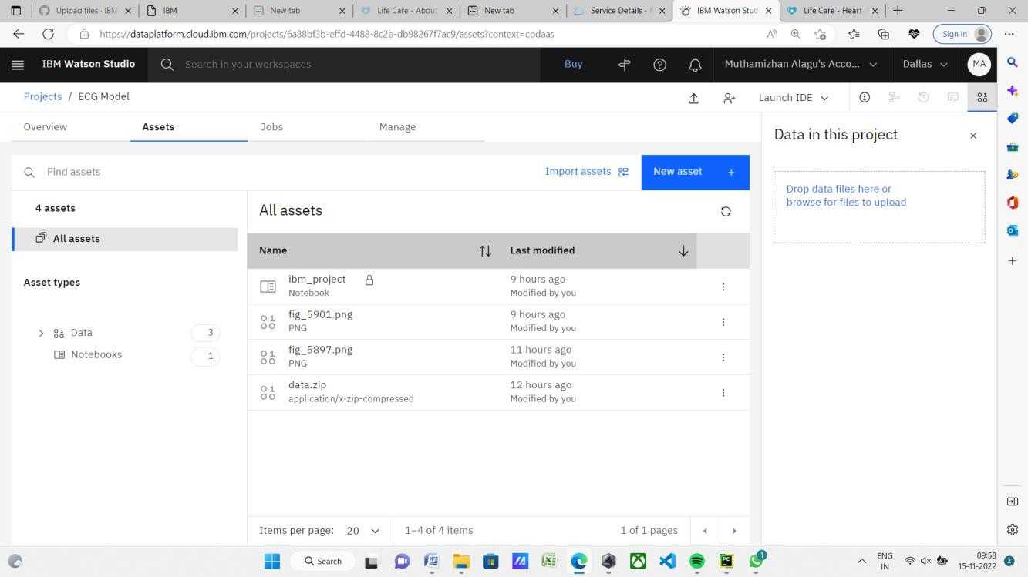

GO ON IBM_PROJECT (SCREEN SHOT):



JUPYTER NOTEBOOK (SCREEN SHOT):

